**East West University**

**Department of Computer Science & Engineering**

**A/2, Jahurul Islam Avenue, Jahurul Islam City, Aftabnagar, Dhaka-1212**

______________________________________________________________________

**Lab Manual : 04**

**Course Code : CSE207**

**Course Title : Data Structures**

**Instructor : Md. Manowarul Islam, Adjunct Faculty, Department of CSE**

**Objective:**

The objective of this lab is to give some basic concepts about QUEUE data structure. After completion of the lab students will know:

* How to create data element in queue
* How to delete data element from queue
* How to perform different operations on queue i.e. copying, compression of string etc.
* Different applications of queue in real life

**Preliminaries:**

A queue or FIFO (first in, first out) is an abstract data type that serves as a collection of elements, with two principal operations: enqueue, the process of adding an element to the collection. (The element is added from the rear side) and dequeue, the process of removing the first element that was added. (The element is removed from the front side). It can be implemented by using both array and linked list.

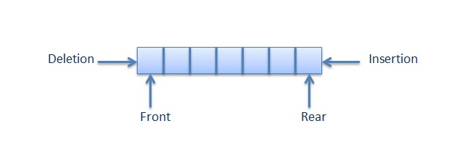

Queue is used when things don’t have to be processed immediately but have to be processed in First in First out order. This property of Queue makes it also useful in following kind of scenarios.

1. When a resource is shared among multiple consumers. Examples include CPU scheduling, Disk Scheduling.
2. When data is transferred asynchronously (data not necessarily received at same rate as sent) between two processes. Examples include IO Buffers, pipes, file IO, etc.

**Lab Task:**

**Exercise 1:**

**Create Queue (Enqueue)**

Create queue allocates a new node for the queue. It first initializes the front and rear pointers to null. If the queue is empty then insert new node in queue and update both the front and rear pointer with the address of the new node and if queue is not empty then update the rear pointer with the address of the new node

**Exercise 2:**

**Delete node from Queue (Dequeue)**

It begins by checking to make sure there are data in queue. If there are, it takes the addresses of the data being deleted , adjust the front pointer and remove the allocated memory space.

**Exercise 3:**

**Print Queue**

The print function will print the entire queue data**.**

**Exercise 4:**

**CopyQueue**

Write a program that copies the content one queue to another

|  |  |
| --- | --- |
| Input Data | Output Data |
| Q1: 1 2 3 4 5 | Q2: 1 2 3 4 5 |

**Exercise 5:**

**Compression of string**

Write a program that compresses a string by deleting all space characters in the string.

Solve the problem using Queue

|  |  |
| --- | --- |
| Input Data | Output Data |
| we are the students of CSE | wearethestudentsofCSE |

**Exercise 6:**

**Stack to Queue Creation**

Write a program that creates a Queue from a stack. After creation the top of the stack will be the front of the queue.

|  |  |
| --- | --- |
| Input Data | Output Data |
| S: 1 2 3 4 5 | Q: 5 4 3 2 1 |

**Exercise 7:**

**Delete all Negative Integer**

Write a program that will take a queue of integers and deletes all negative integers without changing the order of the remaining elements in queue.

|  |  |
| --- | --- |
| Input Data | Output Data |
| Q: 1 2 -3 4 - 5 | Q: 1 2 4 |